Group Gift

By Jacob Gerber, Jacob Biggs, Devon Roe, Jagdeep Singh, Bankole Adegboye, Gabe Mcmahon, James Lewis, and Zack Santee

**Objective and target audience**

Objective: Our objective when making our application was to create an application to allow people to collaborate in the gift buying process. It involves people creating registries for their parties and sharing it with others to make the process easier. Collaboration is mostly in the form of showing users what other users have already bought for the party in order to minimize two people buying the same gift or allow two people to get complimentary gifts that they wouldn’t have otherwise.

Target Audience: Our target audience focuses on adults who have kids, but is not necessarily limited to that group. Most of our design focuses on helping to give those parents a way to organize with other parents to get gifts for the child without having two people get the same gifts. We also saw that it could be used in other forms like with weddings or graduation but those were not the target audiences we primarily focused on.

**Product Research**

* Google Drive
  + First, there is Google Drive that we will be looking at. Put simply, the main functionality of google drive is a combination of a dropbox-like cloud service and a Microsoft Office clone that allows collaboration in real time. The main functions we want to use from Google Drive is its collaborative abilities, especially how it works in real time as people are working and typing. We also would like to use the minimalist design attitude shown in Google Drive as a possible guide for our own designs of our app. These things shown above are what we ended up liking about Google Drive as it pertains to our project. On the other hand, we would not say that there is too much bad with Google Drive in the ways it pertains to our project, just the only problem we had is that it is not terribly similar so we are only looking at some of the functions inside a program vastly different from the one we are designing.
* Amazon
  + Second, we looked at Amazon’s gifting services for our program. Amazon is a shopping service, but we want to specifically use their gift shopping portion for our research. One thing that we liked and want to look at using is the ability for people to create wish lists for others to use when buying gifts. Also, we liked that it did can give gift suggestions for people that might not know what exactly someone wants, so instead can get some suggestions of popular items for that grouping (i.e. young kids, teens, young adults, etc.). We also just wanted to look at the vast amounts of products that Amazon has and how we could get that into our product, either via our own system or a widget that connects into a pre-existing database like Amazon. The main thing that we didn’t like and wanted to improve on is the lack of real time collaboration between people, with most of the site featuring few ways for people to collaborate.
* Remember the Milk
  + The next service we looked at was a web-based reminders service called Remember the Milk. Almost all of the features we were looking for were here--it allows for collaborations, multiple lists can be created, it synchronizes across all devices (and even allows for offline additions), and the base product is free. Unfortunately, the biggest issue is the price. Many of the features listed are only available with a premium account, and at $49.99 a year the price point is a little too much. In addition, even on shared lists everyone needs to have the premium account to use premium features (so everyone would need to pay for the accounts).
* Reminders (iOS)
  + Finally, we have the built-in Reminders app on iOS and other Apple devices. Reminders allows for syncing through iCloud, location-based reminders, multiple lists, and comes free with any and all iDevices. The issue is found with that last point--it’s quite difficult to get Reminders working on non-Apple devices. In addition, the sharing is limited to people on the same iCloud account as the original owner.

**User Study (w/Answers)**

1. Have you ever used an application to arrange events? If yes what application have you used to arrange events? If not have you used anything prior to arrange events?
   1. No, I’ve always arranged events with Phone calls, Facebook or text messages.
   2. No, I’ve never used any application to arrange an event except facebook.
   3. Never an app (just Facebook)
   4. No, not a specialized app
2. How often do you use these applications? Or if previous answer is no, how often do you arrange events?
   1. Normally for my kids birthday and maybe for my wife but not too often though.
   2. I Usually let my husband do all the arranging.
   3. Only when I respond to Facebook event invitations
   4. Not very often. Usually i use Google Calendar for events
3. What type of phone do you use?
   1. Galaxy Note
   2. Iphone
   3. Galaxy
   4. iPhone
4. What is it you like about the application/what do you dislike about it?
   1. Gifting distant relatives like me nieces and nephews. I don’t see them to often.
   2. I’ve never used any of them.
   3. It would be useful if people wanted a gift registry at several different stores instead of one.
   4. I like the group collaboration idea
5. Have you had any difficulties in working an application? If so, what was it you struggled on?
   1. Well, when an app has way too much information. I have used apps that I use for one thing and don’t even use all of the features. I struggle on using all the feature of an app because it feels like I have to use them all.
   2. I’ve noticed that most application don’t have an help option. where you can search or type something you need help on or something you can’t find.
   3. No
   4. Not really
6. Would you prefer using an application for future events? Such as planning for a party/ get together.
   1. If wouldn’t prefer it but I am open to try it. If it’s good enough then maybe I would prefer to use.
   2. I would definitely use an application like that, if it's not too complicated.
   3. That would be convenient
   4. If it was easy to use, yes
7. Would you recommend others using this application?
   1. If it is easy to use and simplified enough for someone my age.
   2. If i like it, I will definitely suggest it to other people.
   3. If it worked well
   4. It has to be simple, for the old folk (laughs)
8. Do you find this application to be trustworthy?
   1. If it is secure and convenient for me. I’m not concerned about everyone else.
   2. Depends on the review of the application.
   3. NA (I guess it would depend on what permissions it asked me to approve)
   4. Hard to say with just a concept. If it’s google, i trust it
9. Would you use an application for more professional gatherings, such as meetings?
   1. Probably for meetings outside of work or for the kids parents that I couch. We already have applications here at work to do that. Company Policy.
   2. I would definitely if i like it. I would use for all the gathering and meetings.
   3. yes
   4. If it is simple to use, absolutely
10. If you think this application needs improvement, then what would it be on?
    1. My guess is explaining how the application works. Maybe explaining a step by step process of what happens when the donation is made in the application. Right now I would be skeptical about it.
    2. I’ve never used an application like this but my guess would be most application are really complicated to use at first.
    3. Maybe it could link to the online stock of a store (so you know when an item is out of stock at a location)
    4. Simplistic design. Make sure the button says what it does.
11. Would you like your social media connected with that application?
    1. I don’t mind as long as this application doesn’t post to my account every time I do something. Heck, maybe it’s a surprise
    2. Definitely because that will help me invite all my friends and family.
    3. No (but I tend to keep my social media accounts and apps all separated).
    4. I suppose, but i need complete control over who gets to see it
12. Would you like that application to send you notification or alerts?
    1. Only at certain times. I like Facebook because it tells me when someone's birthday is coming up. Maybe the app could remind me of the same thing. Maybe that’s why facebook would link to the app?
    2. There should be an option where it will let me enable and disable the notifications.
    3. If it was related to a registry I was a part of?...options for alerts would be best?
    4. As long as i can turn them off if someone gets noisy (laughs)
13. From 1-5 (1=simple 5= extremely simple)how simple do you want that application to be?
    1. What do you think? A 5!
    2. Definitely 5.
    3. 5
    4. Haha, a 5 obviously.

**User Study Findings**

Things we found from our user research:

* People don’t use dedicated apps for organizing parties, only app people use for those purposes is Facebook
* People organize parties very rarely, or rely on others to organize it for them
* It would be important for us to design for both iOS and Android as there seems to be a decent distribution of the phones in the audience.
* The ability to collaborate over distance is one of the major benefits of our app
* A common problem is information overload and then lacking any sort of ‘Help’ functionality
* People would be open to trying our app if it worked well
* People would recommend our app to others if it worked well
* Application security is important to users
* Making sure to have some sort of tutorial or help section is something people deem useful and necessary
* Opinions on Social media integration vary between people
* Alerts and notifications from the app should be customizable and infrequent
* Users want the most simple application they can get

**Our persona**

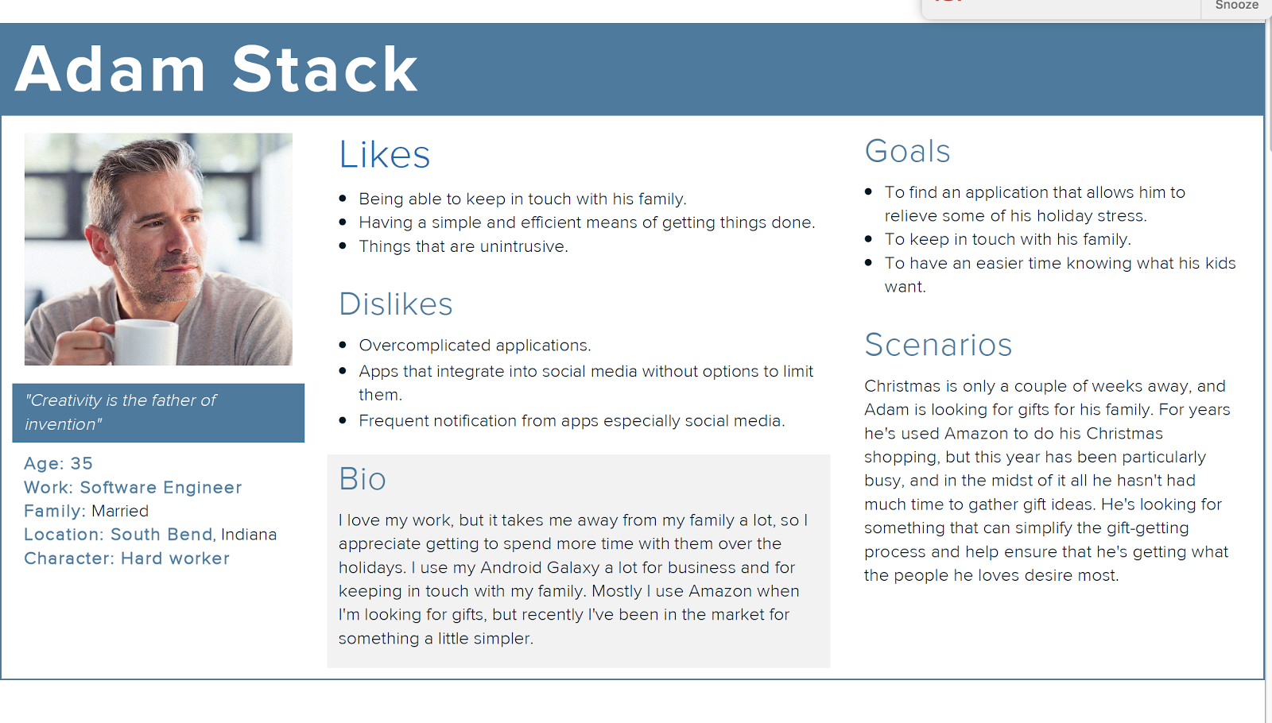

**Our Designs**

Bankole Adegboye’s wireframes ----

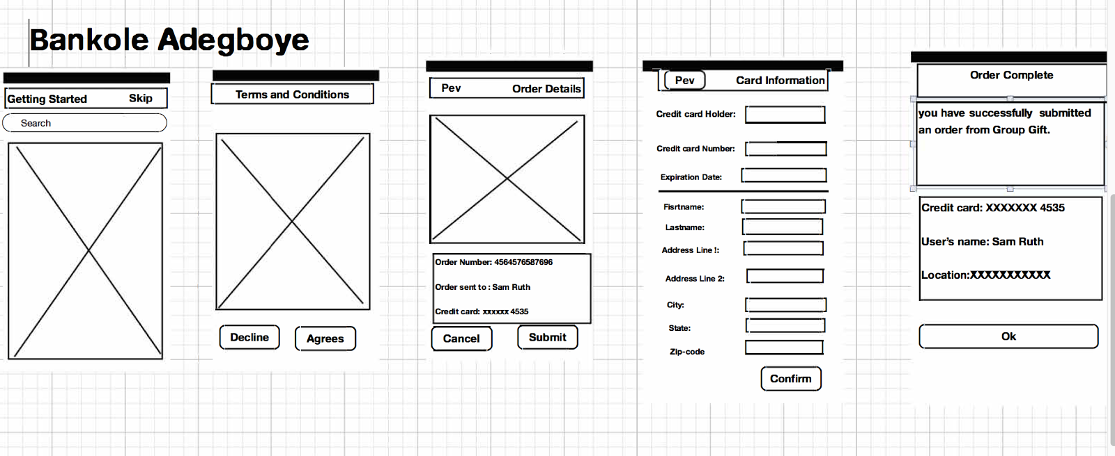

Jacob Gerber’s Wireframes ---

**Attached to project in separate folder**

Jacob Biggs’ Wireframes ----

**Attached to project in separate folder**

Devon Roe’s Wireframes ----

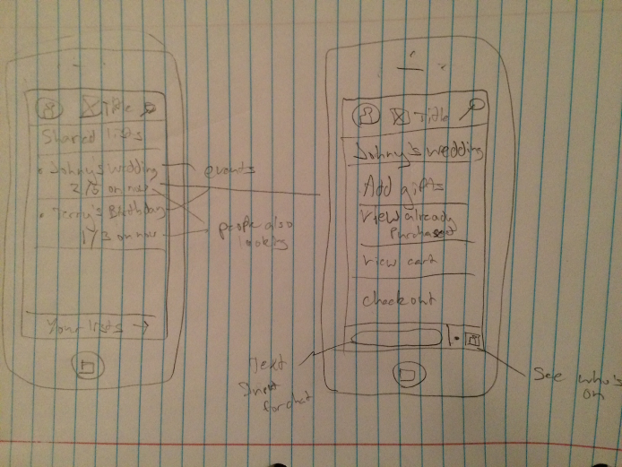

James Lewis’ Wireframes ---

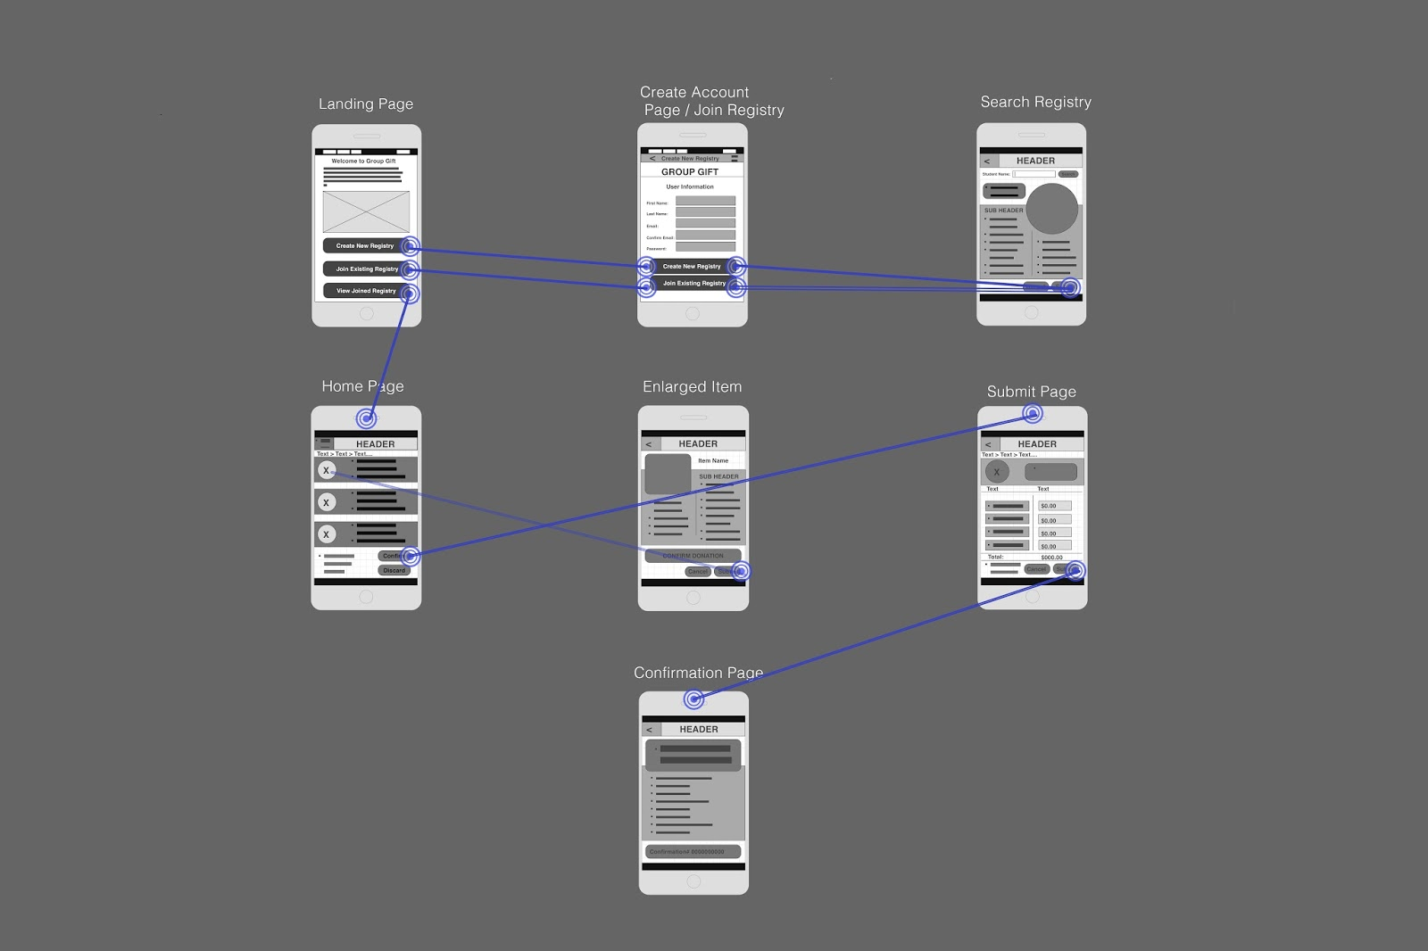

Jagdeep Singh’s Wireframes--

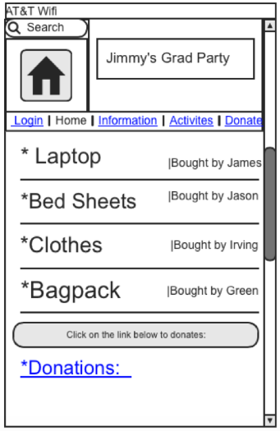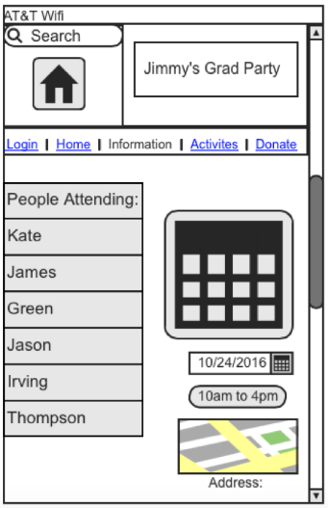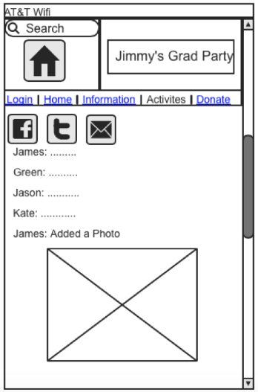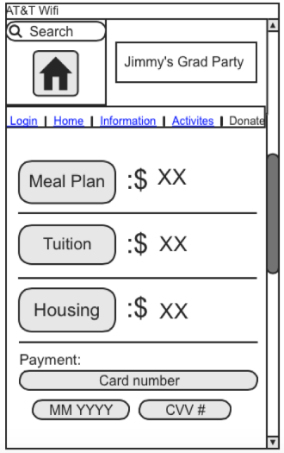

Gabe McMahon’s Wireframe ---

**Attached to project in separate folder**

Zack Santee’s Wireframe ---

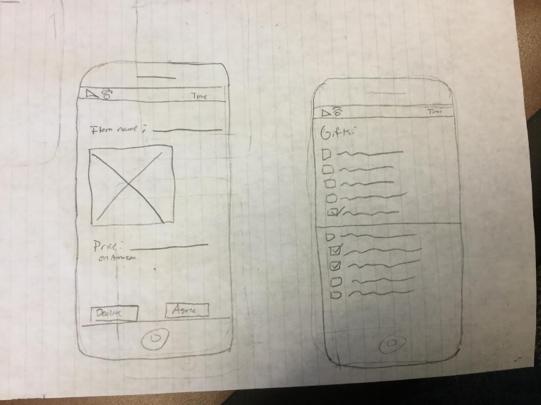

**Design Choice Rationale**

For our chosen design, we decided to go with a hybrid between Jacob Gerber’s design and James Lewis’ design. We will be using James’ design as a base and using some of the ideas from Jacob’s design to add some functionality to our design. We liked the overall look of James’ design, especially its simplistic use of minimalistic design, which is why we decided to use it as our base. We then took some of the other functions and ideas from Jacob’s design because there were a few ideas that we decided should be added to our end design.

**Low Fidelity Prototype**

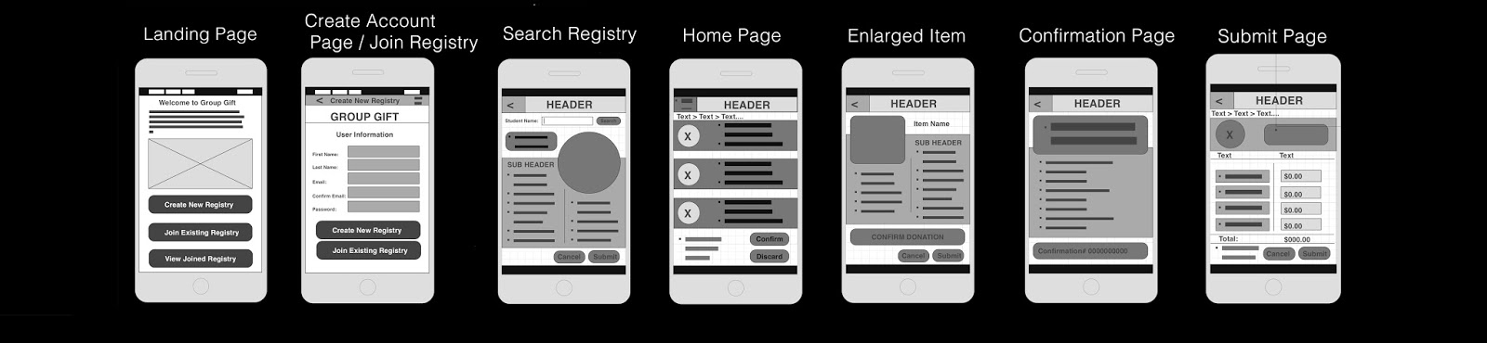

**Usability Test (w/responses)**

**Introduction:**

GroupGift is an online collaborative gift registry. The goal of this test is to determine the overall ease of use for this app. During this test, you will be asked to perform a series of tasks that an average user will perform while using this app. You will be asked to join an existing registry, select an item to donate, confirm your donation, and make a cash donation. You will also be asked a series of questions before, during, and after the test. I will be reading from these notes to ensure consistency throughout the test. Your results will be written down and will remain anonymous. Please know that what you’re about to test on is low fidelity and some things may be not very detailed.

______________________________________________________________________

**Pretest Questions:**

Have you ever used a registry for an event before?

(G) - Yes, a wedding

(J) -   Yes

(D) - Yes

Have you ever used a gift registry app before?

(G) - No

(J) -  No

(D) - No, Didn’t know it was a thing

Would you prefer to use an app to keep track of your registry?

(G) - I suppose. I wouldn’t forget it at home by accident (laughs)

(J) -  Yes, I think that would be really helpful.

(D) - I guess if it’s easier

Have you ever been in a position where two people had purchased the same gift?

(G) - Once. That was embarrassing

(J) -  No, but i’ve seen some people bring in the same gifts.

(D) - No

Have you ever wanted to just give money rather than a gift?

(G) - Absolutely. Especially for older kids

(J) - Yes, But i don’t like doing that.

(D) - Yes, I suck at giving gifts

Does your cell phone have a stable internet connection?

(G) - yes

(J) - Yes

(D) - Yes

______________________________________________________________________

**Procedure:**

For this task we ask that you confirm your donation of an item and make a cash donation after joining an already existing registry.

Landing page

* Describe out loud what you see and what you think the first step is here.
  + - (J) First thing i see on the application is that you have to create a account.
    - (D) I see three different options for an account.
    - (G) Seems to me like a login or register page
* What do you think you should click on in order to accomplish the task.
  + - (J) Click on the create new Registry option.
    - (D) New registry
    - (G) Create new registry?
* What do you think will be on the next page?
  + - (J) I think it will ask me for my information, like most application do when you create an account.
    - (D) No idea haha
    - (G) Probably a generic login page
  + Go ahead and click to the next page

Join Registry page

* Describe the page. Is this what you were expecting?
  + - (J) This page is asking me for information to sign up but Yes, this is exactly what I was expecting.
    - (D) It makes sense
    - (G) Looks just like a “create account” page. I was expecting this
* What do you believe is the next step?
  + - (J) The next step would be to answer all the questions and create a new Account.
    - (D) Fill out the blanks and continue
    - (G) Fill in the form and hit one of those buttons
* What do you think will be on the next page?
  + - (J) I think it’s going the ask me to login with the same information that i Added, to use the application.
    - (D) Again I don’t know haha
    - (G) Not sure, which button am i supposed to press?
  + Go ahead and click to the next page

Registry Home page

* Describe the page. Is this what you were expecting?
  + - (J) I guess it’s some kind home wall like facebook? No, i was wrong this was not what i was expecting.
    - (D) Different items. Not at all.
    - (G) Uhhhhh, i’m not even sure what this page is (laughs)
* Locate and select an object that you wish to donate.
  + - (J) How would i do that? Oh, i think i would search it by the name.
    - (D) Is there a search bar, oh I see it.
    - (G) Is it these circles? Oh, ok
* What do you think the next page will look like?
  + - (J) I believe it’s going to bring a lot of option for me to select the object from.
    - (D) Checkout maybe?
    - (G) Details page? Hard to tell
  + Continue on with your order.

Enlarged Item Page

* Describe the page. Is this what you were expecting?
  + - (J) I think this page describes the item i have selected but No, i was not expecting this.
    - (D) or a confirmation page
    - (G) Sort of? I expected something similar
* Make sure that this is the correct item that you wish to donate.
  + - (J) I would do that by looking at the details and Item name.
    - (D) Yes, I want to buy it
    - (G) Sure
* What should you do here to continue?
  + - (J) I believe i would click on confirm Donation tab.
    - (D) Click confirm?
    - (G) Confirm i think
* What do you think will happen next?
  + - (J)I think next page is going to ask me for my information again.
    - (D) Now checkout
    - (G) Probably a confirmation page of some sort
  + Go to the next page.

Confirmation Page

* Describe the page. Is this what you were expecting?
  + - (J) Looks like this page is going to give me all the confirmation information. No this is not i was expecting.
    - (D) This looks like checkout
    - (G) Looks like a receipt of some kind
* Now you need to make another donation through the Registry Home Page.
  + - (J) Okay, but i do go back, you click on that arrow button?
    - (D) Alright go home
    - (G) back arrow, like iphone?
* How do you think you can get back to the Registry Home Page?
  + - (J) I think you click on the arrow button the top by the header to go back.
    - (D) Click the logo?
    - (G) It’s that back arrow right?
  + Click on the back button to return to the home page.

Home Page

* Now you’re here to perform a money donation.
  + - (J) I think i would click on the money option, but i don’t know what those options are on the screen.
    - (D) Donation
    - (G) I don’t see a donate button
* How do you think you should go about doing this?
  + - (J) I think just click on the money donate option and click confirm.
    - (D) Type in an amount
    - (G) i have no idea. Where’s the donate or money button?
* What are you expecting to see once you continue?
  + - (J) Somewhere i could put how much money i want to donate.
    - (D) Another confirmation page
    - (G) Something like paypal i guess? Amazon-esque?
  + Click to the next page.

Submit Page

* Describe the page. Is this what you were expecting?
  + - (J) Looks like on this page we’ll add amount that we want to donate. Yeah i was wondering, where would i type the amount i want to donate.
    - (D) Yes
    - (G) Looks about right
* Here you need to type in the desired amount that you wish to donate.
  + - (J) Okay, pretty simple.
    - (D) Yes
    - (G) Alright
* Insert the amount and complete your order?
  + - (J) Okay.
    - (D) Easy
    - (G) Alright
* How would you complete your order?
  + - (J) Type in the amount and click submit.
    - (D) Submit
    - (G) Should be submit
* What do you think will happen?
  + - (J) I think it will give me my confirmation number or something like that.
    - (D) Process my order
    - (G) Hopefully a confirmation like Amazon if i’m paying money (laughs)
  + Finish the order.

Confirmation page

* Congratulations, you have completed the required tasks.

**Post test Questions:**

The following questions are just to ask you about your thoughts on the test and any recommendations you may have for us. Please remember that your responses are anonymous.

1. Did you find the pages easy to understand and maneuver?

(G) - You said this was not final? It was difficult to figure out just because of the lack of text

(J) It was to find out a lot of things since it’s not completed yet.

(D) Very simple design, I’m not use to these symbols though

1. Do you think you would be able to perform these actions on your own?

(G) - With the current design? No. If there was text instead of lines maybe.

(J) Yeah i think so, if i start using this application often i will be fine.

(D) Probably on the finished build

1. Have you ever used an application similar to this?

(G) - Not really. I guess the closest thing would be Reminders in iPhone

(J) No I have not so far.

(D) Yes, not  registry app though

1. On a scale from 1-5 (5 being most likely), How likely are you to use a final version of this application?

(G) - I think a 3 sounds fair. Especially if I get to see a final design

(J)   Depends on the final design comes out.

(D)  if it’s good

1. Do you have any recommendations on how our design can improve?

(G) - Hard to say without seeing what text goes where. Just make sure the ‘next’ button is very very clear (laughs)

(J) Hmmm, Maybe add an option that will take you to home just by clicking on it. But other than that looks good to me.

(D) It seemed pretty straight forward. Maybe, put in a shopping cart feature so I don't have to check out one at a time.

**Usability Test Findings**

Problems Users Had:

* Users were not sure how to go back to the homepage.
* Users wanted to have a simpler way of getting to the shopping cart/checkout.
* Users were having struggle finding “next” button.
* All of our users thought that the design was really simple and easy to use.
* We  found that users have never used an gift registry application before.
* Users expectations of screens were often wrong
* Users were confused of how app works at times.

Feedback from Users:

* Users thought that the design was really difficult to figure out just because it was low fidelity prototype.
* Users respond that they would recommend this application 3 out of 5 people.
* Most of our users said that they will be able to perform the task alone when the design is finished.
* Users preferred to use the app if it simplified the gifting process
* Make buttons more clear to see
* Users were able to identify how to do tasks on different pages.

**High Fidelity Design**

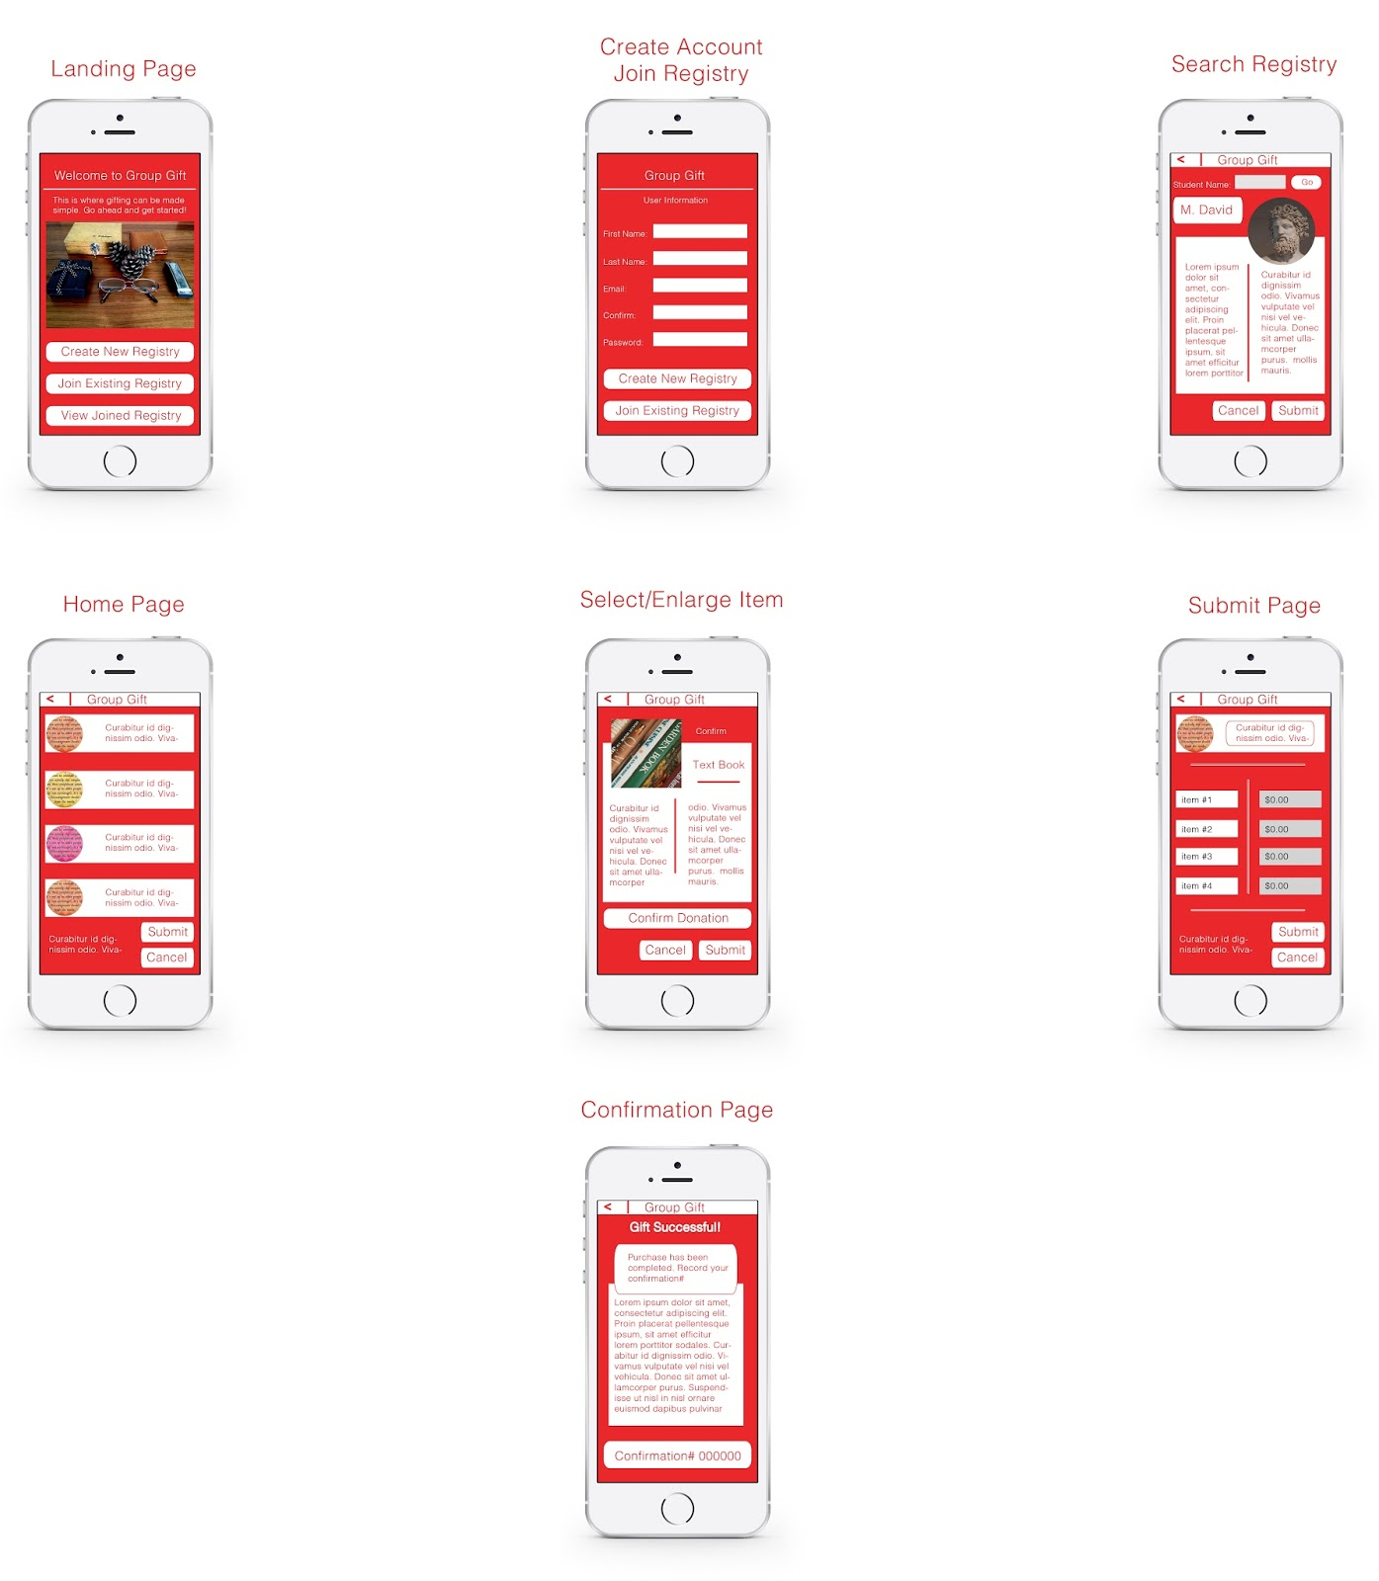

**Note: Our Landing Page has changed. Here is our new one:**

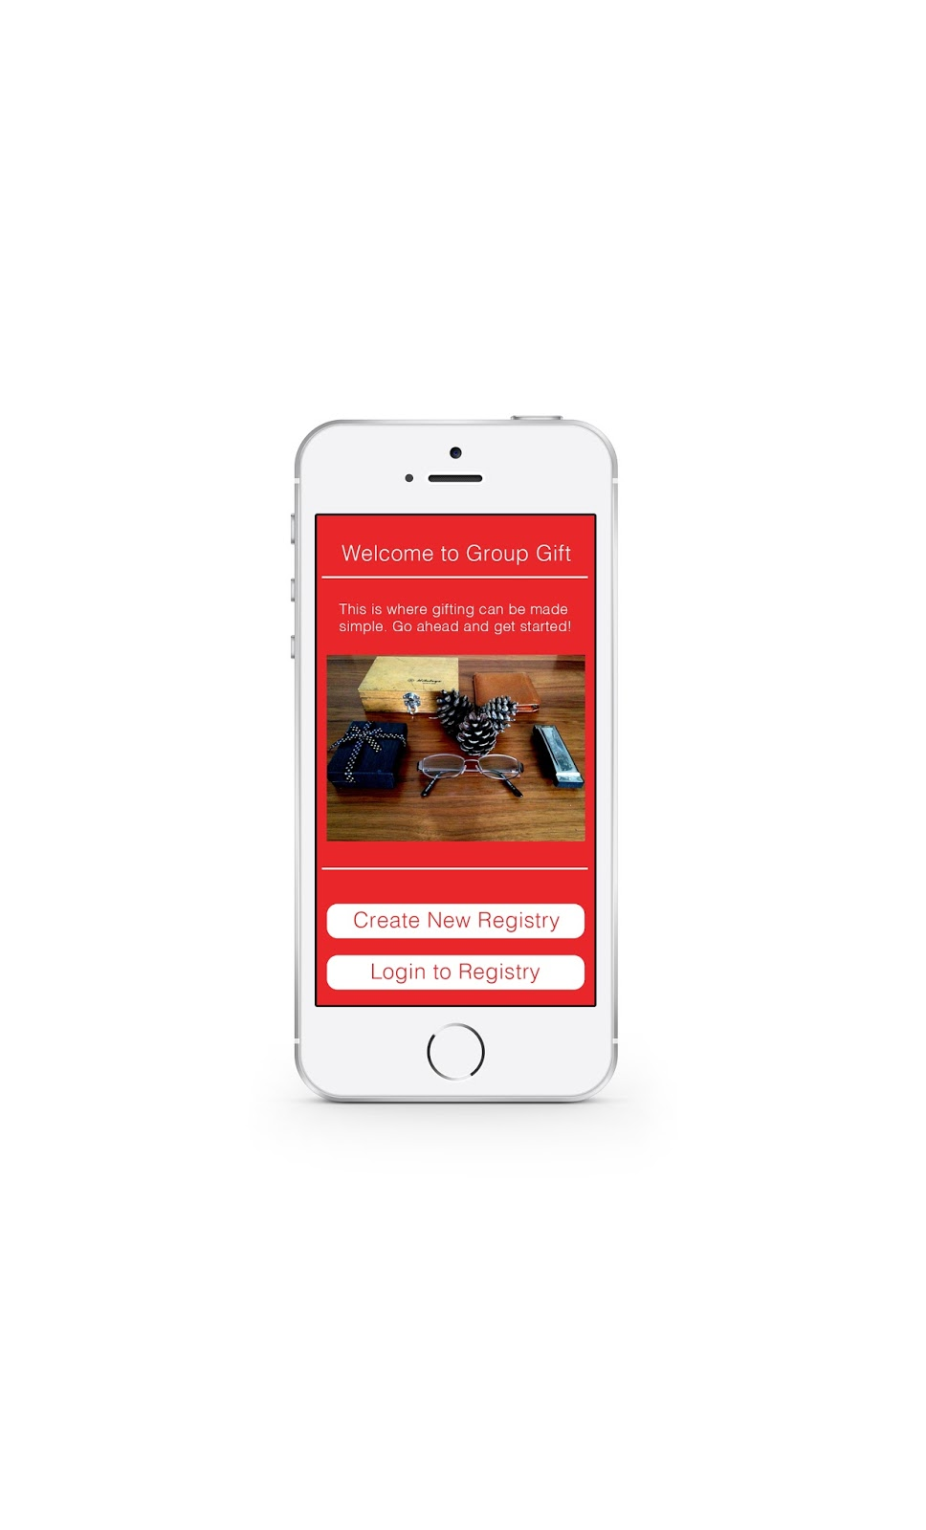

**Project Presentation**

Presentation is attached